
A
Practical Assignment
On
New Age Life Skills
Bachelor of Computer and Applications
1
^{st}
SEM
RUNGTA INTERNATIONAL SKILLS UNIVERSITY
SESSION: 2025-26
Submitted By:-
Mrs. Priya Das
Kanij Ayesha
(
Lecturer
)
RU-25-10647
Submitted To:
RUNGTA INTERNATIONAL SKILLS
UNIVERSITY, C.G
SCHOOL OF COMPUTER SCIENCE ENGINERRING

iINDEX
S.No | Name Of Practical | Submisson Date | Remark
1. | Design a professional resume using templates. | 22-09-2025
2. | Create a Career Oriented Presentation with 7 slides using transitions and animations. | 29-09-2025
3. | Create a social media poster for “DIGITAL AWARENESS  WEEK”  using canva. | 01-10-2025
4. | Compose & send a professional email with an attachment as “you are applying for an internship, send email to HR with your resume attached”. | 06-10-2025
5. | Design a complete Google Form survey and analyze responses.  - Create a Google Form titled “Student AttendenceReport”.  - Include the following question types:  - 5 MCQs  - 1 Rating scale (1–5)  - 1 Short answer  - 1 Checkbox question  - Customize the theme (header image + color).  - Share the form link with 5 friends andcollect responses.  - Generate charts from responses andtake screenshots of the analysis page. | 11-10-2025
6. | Demonstrate the creation and management of your digital identity.  - Create a social media profile(LinkedIn preferred).  - Add a profile photo, short bio, skills,and education details.  - Create a simple post about “My Learning  Journey in Digital Literacy.” | 31-10-2025

d) Change your privacy settings to:
- Who can see your posts.
- Who can message you
7. | Using Google Drive or OneDrive:  - Create a new folder named “Unit 3 PracticalWork”.  - Upload 3 different files (PDF, image, document).  - Organize them in subfolders: Notes,Images, Assignments.  - Share the main folder with your teacher withView Only permission. | 13-11-2025
8. | Identify one real phishing email : A final-year student, Aman, receives a LinkedIn message saying:  “You are shortlisted for a Remote Software Developer role at Google.  Salary: ₹18 LPA.  Pay ₹2,499 as verification fee.  Limited seats. Pay now to confirm.”  ANSWER THE QUESTIONS :-  - What type of cybercrime is happening here?  - List 3 red flags that show it is a scam?  - What should he do to verify if a job offer is real? | 19-11-2025
9. | Create a Google Form Quiz with the following requirements:  - Convert the form into a Quiz mode withautomatic grading.  - Add 5 MCQ questions, each carrying 2 marks.  - Add 1 short answer question that requiresmanual evaluation.  - Turn ON the setting:  - Limit to 1 response  - Shuffle question order  - Release marks after manual review  - Add a timer add-on (like form presenter) and setup a 10-minute time limit.  - Finally, send the quiz link and view the response | 24-11-2025

 | summary.
10. | Ask ChatGPT OR Google Gemini to generate a 100–120 word paragraph on:  “Is online learning better than offline learning for college students?”  - Run the AI-generated text through  Grammarly and any plagiarism-check tool.  - Now manually search online to check ifsimilar sentences exist on blogs or articles.  - Identify 2–3 biased statements in the AIanswer, such as:  - Over-generalizations  - One-sided opinions  - Unproven claims  - Rewrite the entire paragraph in a neutraland balanced way, using AI only for grammar suggestions.  - Submit 3 screenshots:  - Plagiarism check result  - Grammarly suggestion page  - Original AI paragraph vs your rewritten unbiased version | 29-11-2025
11. | To compare AI-generated content with student-created content and understand limitations of AI.  - Write a 100–150 word paragraph onthe topic:  “Will AI replace jobs or change them?” (This must be written by the student.)  - Ask any AI tool  (ChatGPT/Gemini/Copilot) to write the same topic.  - In your practical copy, create a  Comparison Table with the headings:  - Human-Generated Content  - AI-Generated Content | 03-12-2025
12. | Create a new NotebookLM project titled: “My Chapter Revision Notes.” | 10-12-2025

- Upload multiple sources (any 2) such as:
  - PDF notes
  - Web articlesiii. Text copied into NotebookLM
- Ask NotebookLM to:
  - Create a combined study guide usingall sources.
  - Generate flashcards for quick revision.
  - Create a concept map or explanationof the topic.
- Manually check for:
  - Any incorrect facts
  - Repeated informationiii. Missing important points
- Attach 3 screenshots from NotebookLM:
  - Combined study guide
  - Flashcardsiii. Concept map / explanation
13. | Create a complete Student Result Management workbook.  - Create a new workbook with 3 sheets renamed as:  - Student_Data  - Marks_Analysis  - Charts  - In Student_Data, enter a list of 15 students with: Name, Roll No, Class, City, Subject1, Subject2, Subject3.  - Use Flash Fill to split “Full Name” into “FirstName” and “Last Name”.  - Use Find & Replace to replace city name“Delhii” with correct “Delhi”.  - Use IF function to calculate Pass/Fail (Pass = total  ≥  120).  - Use COUNTIF to find how many students belongto  “Delhi”.  - Use AVERAGE, MAX, MIN to analyze marks inthe | 19-12-2025

Marks_Analysis sheet.
- On the Charts sheet, create:
i. A Bar Chart showing marks of any one subject. ii. A Pie Chart showing percentage of pass vs fail.
- Apply Conditional Formatting to highlightmarks < 40 in red.
- Convert the table into a formatted Excel Table.

14. | Build a workbook for managing and analyzing sales data of a small store.  - Create a workbook with sheets:  - Store_Sales  - Summary  - Charts  - Import a CSV sales file (or create a sampletable) containing:  Date, Product, Category, Quantity, Price, Total Sales.  - Use Sort (A→Z, Z→A) to organize products byname and category.  - Apply Filter to view only “Electronics” category.  - Use SUMIF to find total sales for a selectedproduct  (e.g., “Headphones”).  - Use LEFT, RIGHT, MID to extract:  - First 3 letters of the product name  - Last 2 letters of the category  - Find the highest and lowest sales valueusing MAX/MIN.  - Prepare a monthly sales summary in the Summary sheet using AVERAGE & SUM.  - Create a Line Chart of month-wise total sales inthe  Charts sheet. | 24-12-2025
 | j) Apply sheet protection so data cannot be edited accidentally.

15. | Create a complete personal financial planner workbook.  - Create and rename sheets as:  - Expenses  - Budget  - Charts  - Enter at least 20 rows of expense data:  Date, Category, Expense Detail, Amount, Payment Method.  - Use Data Validation dropdown to create acategory list (Food, Travel, Fees, Shopping, Other).  - Use Remove Duplicates on the Category columnif repeated incorrectly.  - Use SUMIF to calculate total spending foreach category.  - In the Budget sheet, create the monthly budget and compare with actual expenses using:  Difference = Budget – Actual (formula required)  - Highlight expenses above ₹2000 usingConditional Formatting.  - Create:  - A Pie Chart showing category-wise spending  - A Bar Chart comparing Budget vs Actual  - Use Flash Fill to separate date into Day / Month / Year if needed. Also explain its detail  - Save worksheet in Page Layout view and adjust print area. | 29-12-2025

QUESTION 1
Design a professional resume using templates.
Sol:
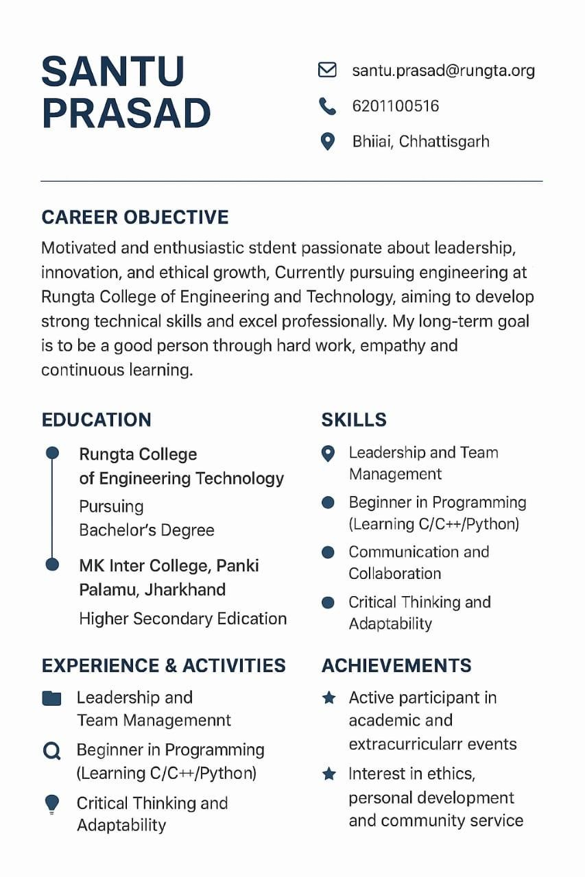
kanijl.ayesha@rungta.org
KANIJ
AYESHA

QUESTION 2
Create a Career Oriented Presentation with 7 slides using transitions and animations.
Sol:
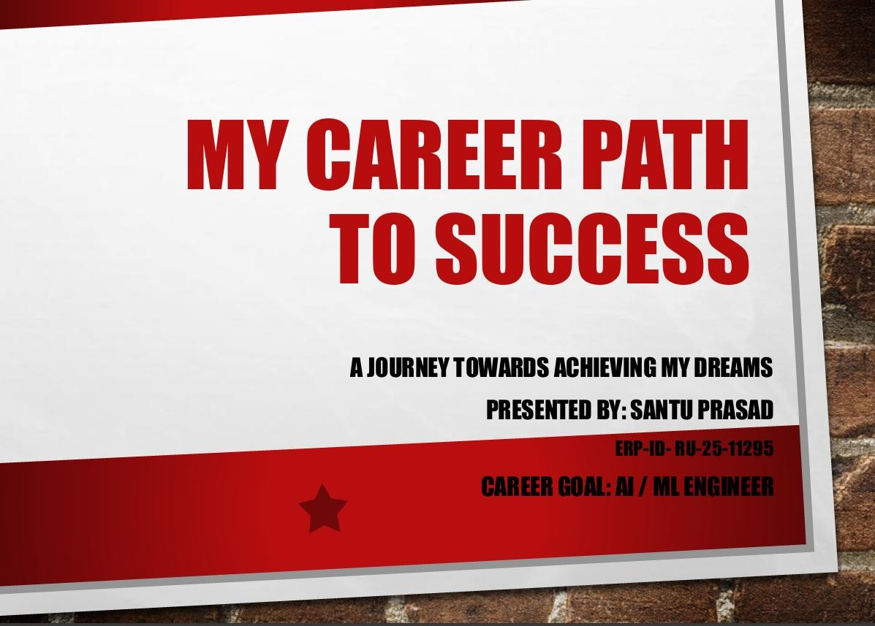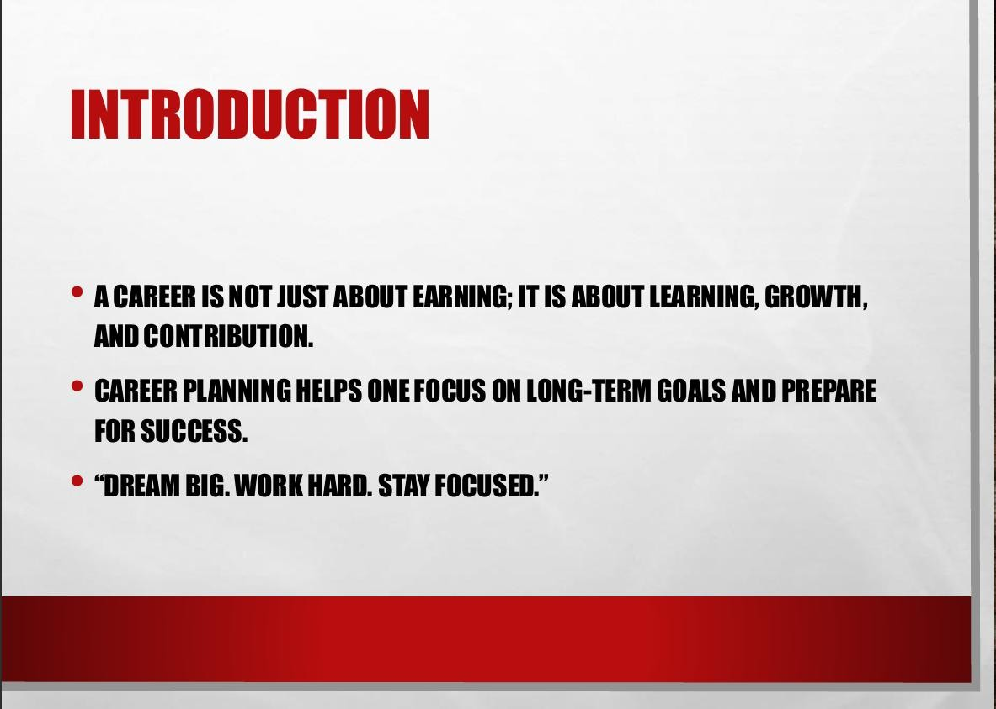
ERP-ID-10647
PRESENTED BY – KANIJ AYESHA

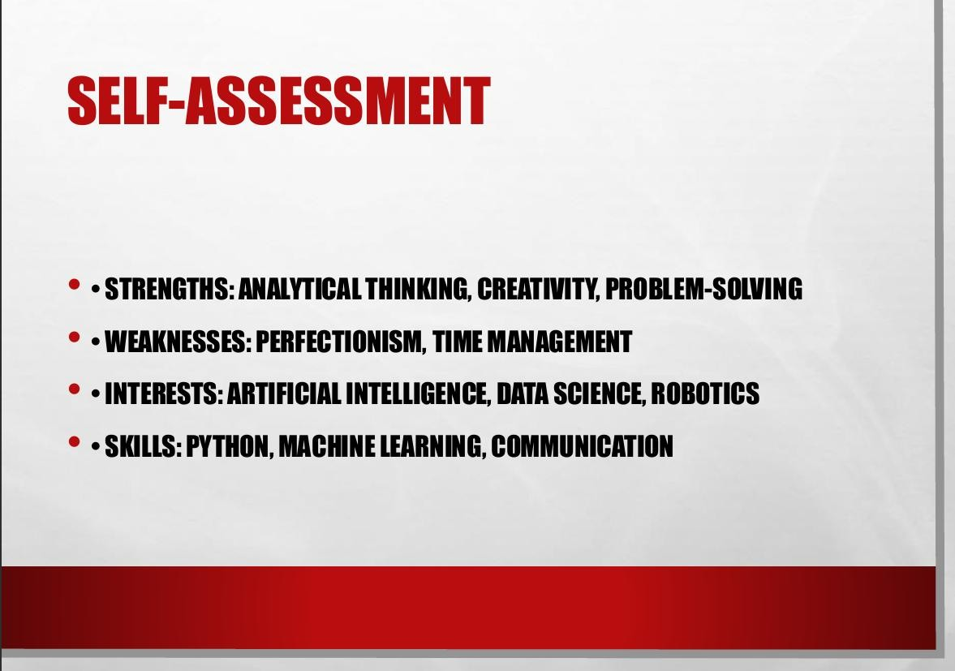
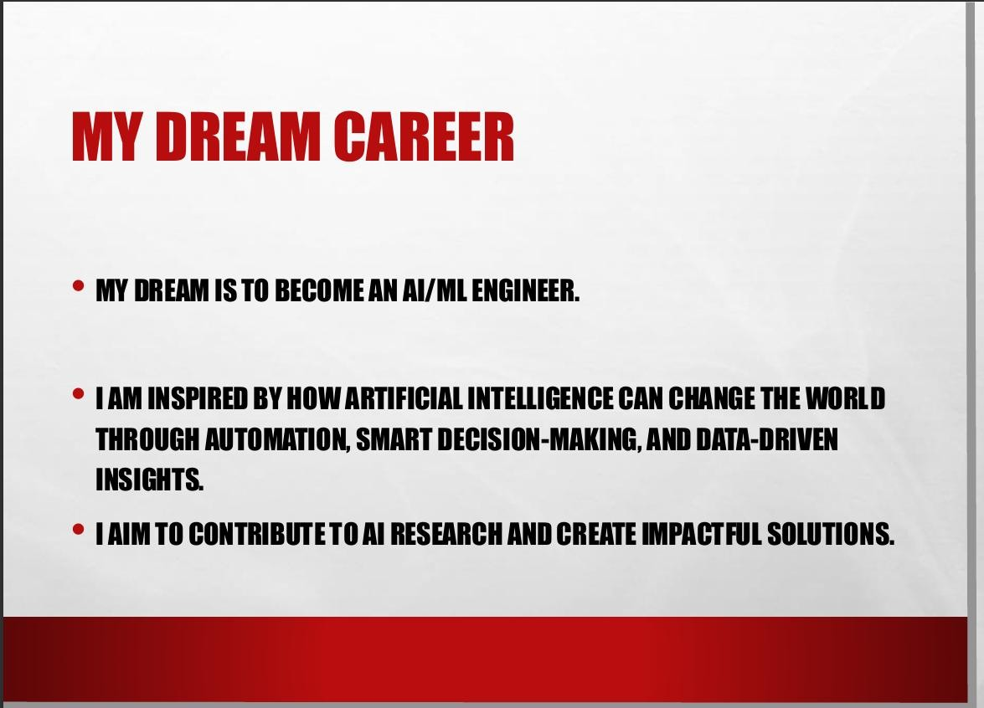
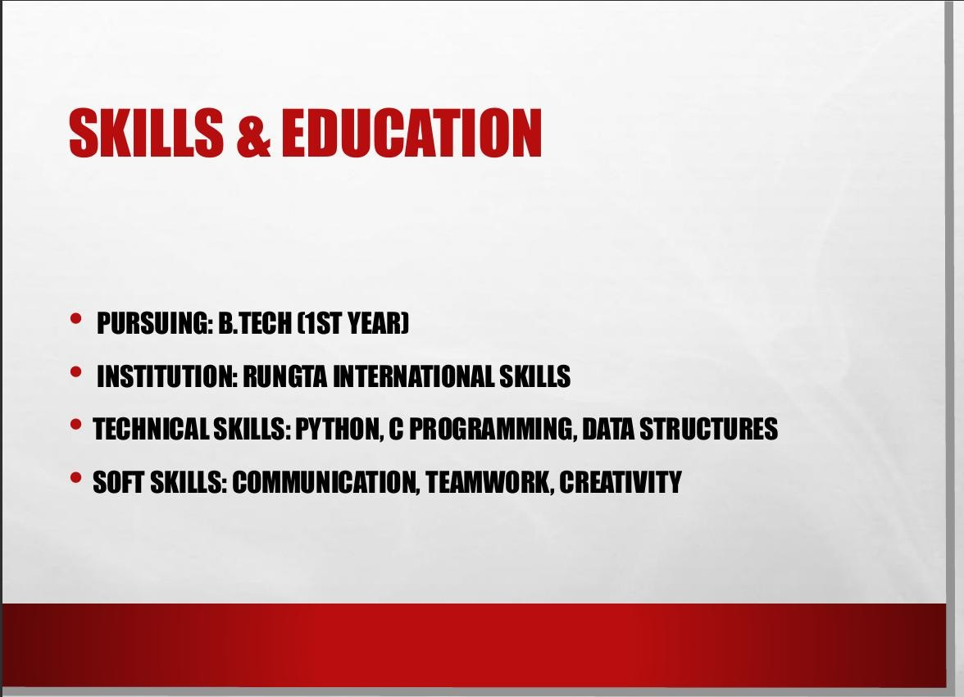
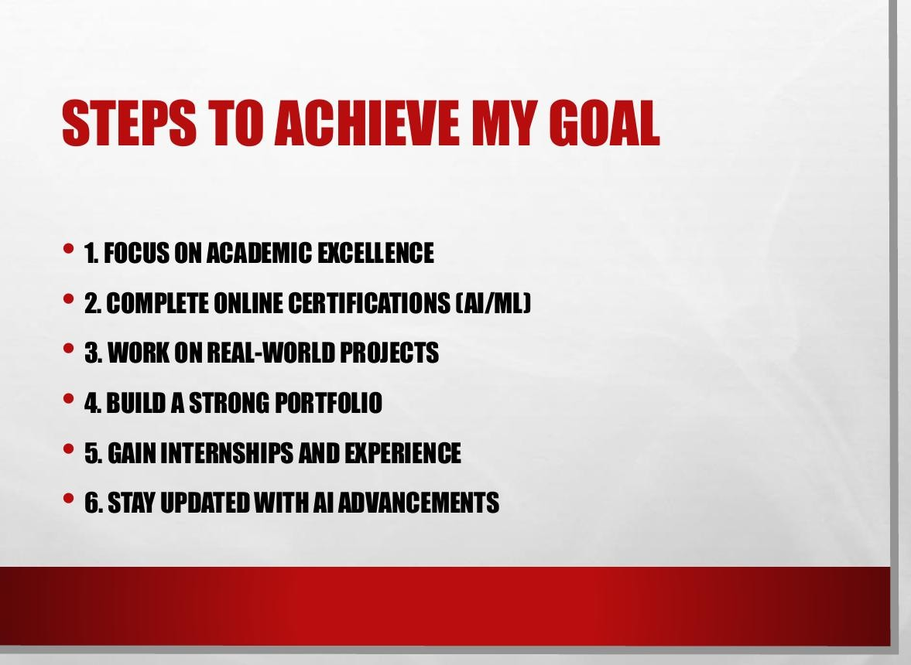
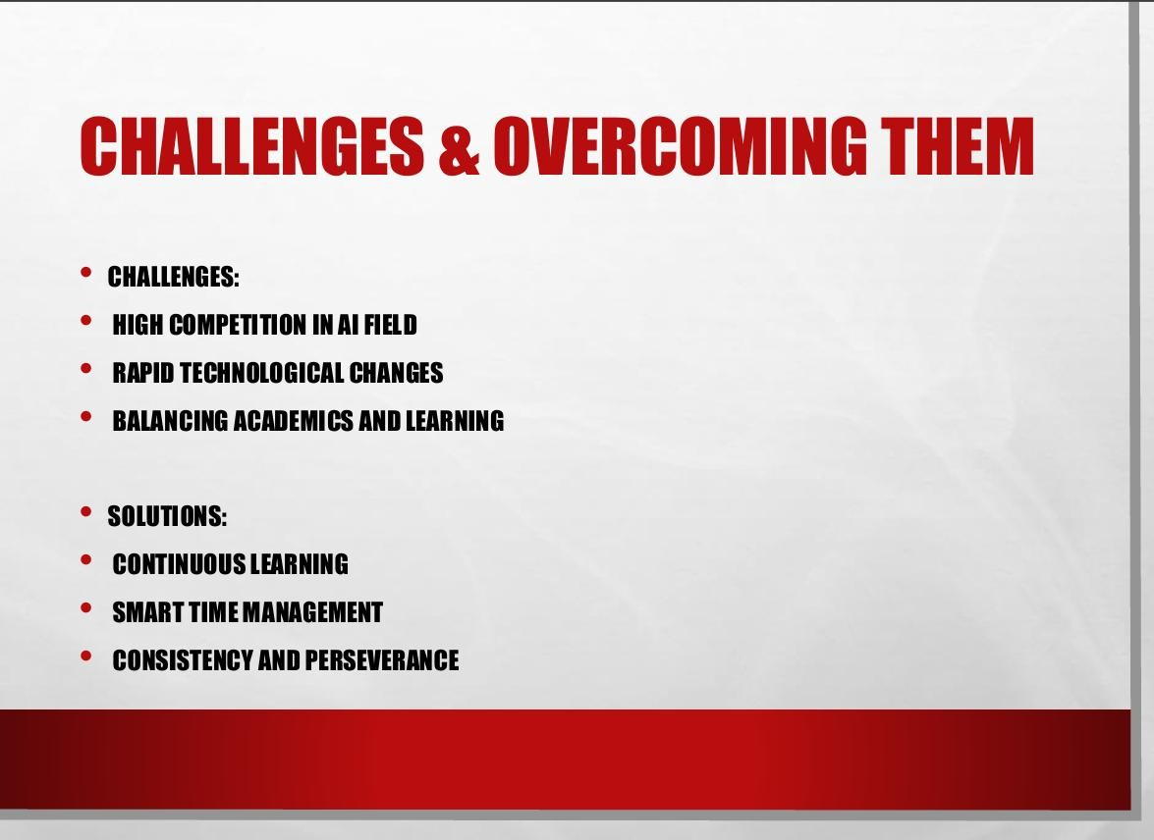
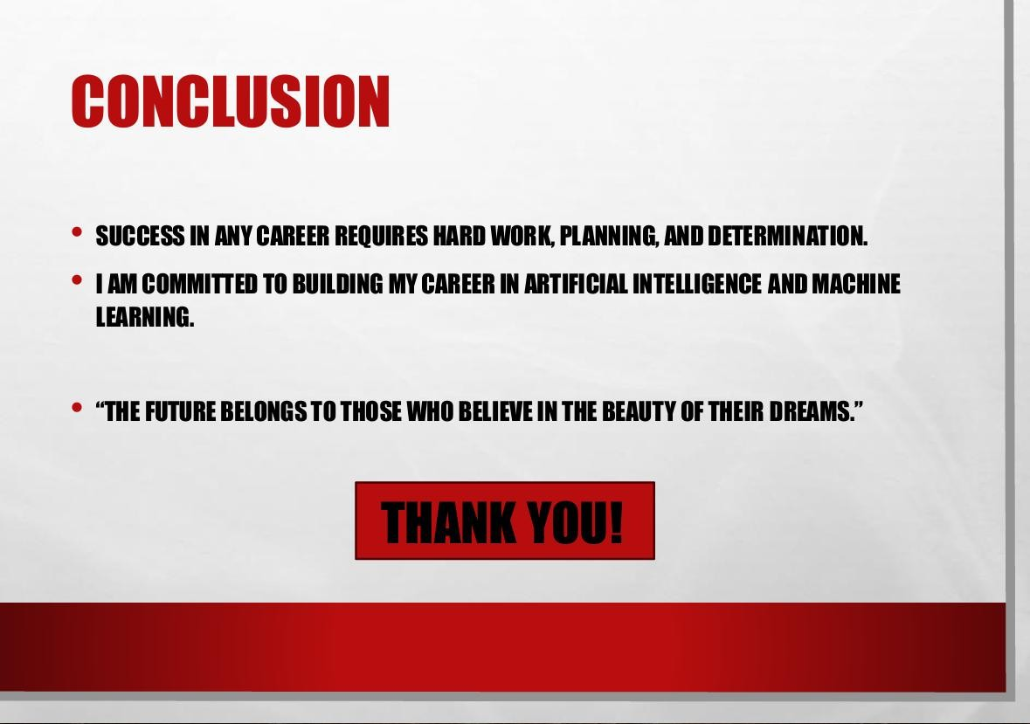

Create a social media poster for “DIGITAL AWARENESS WEEK” using canva.
Sol:
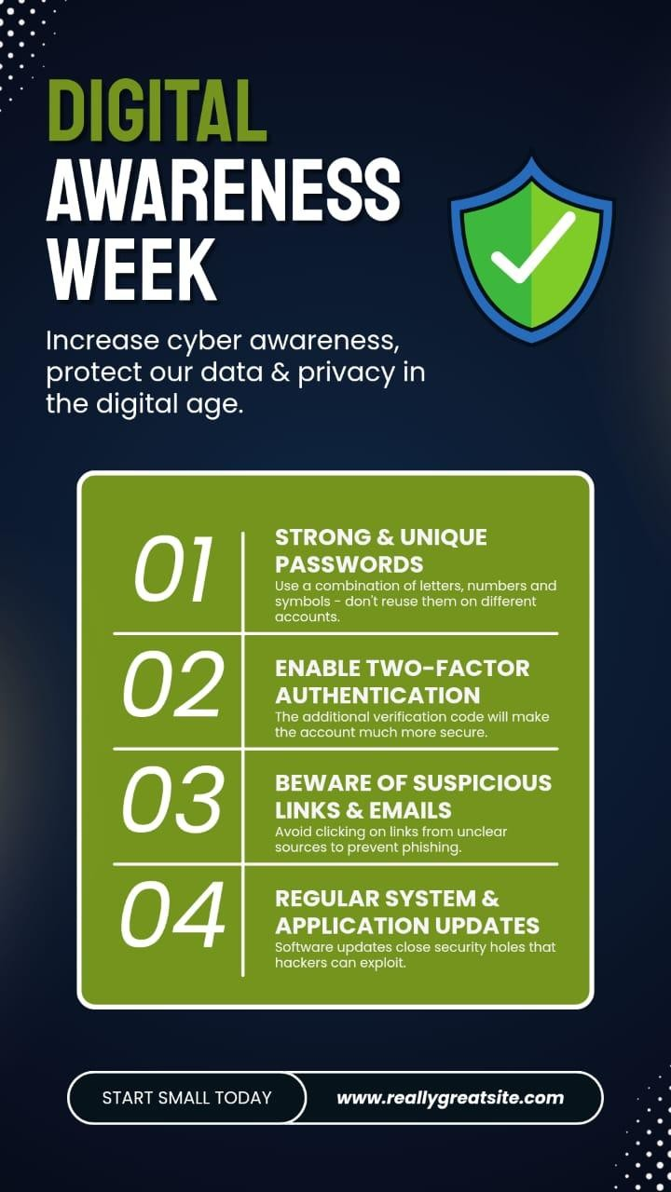
Compose & send a professional email with an attachment as “you are applying for an internship, send email to HR with your resume attached”
Sol:
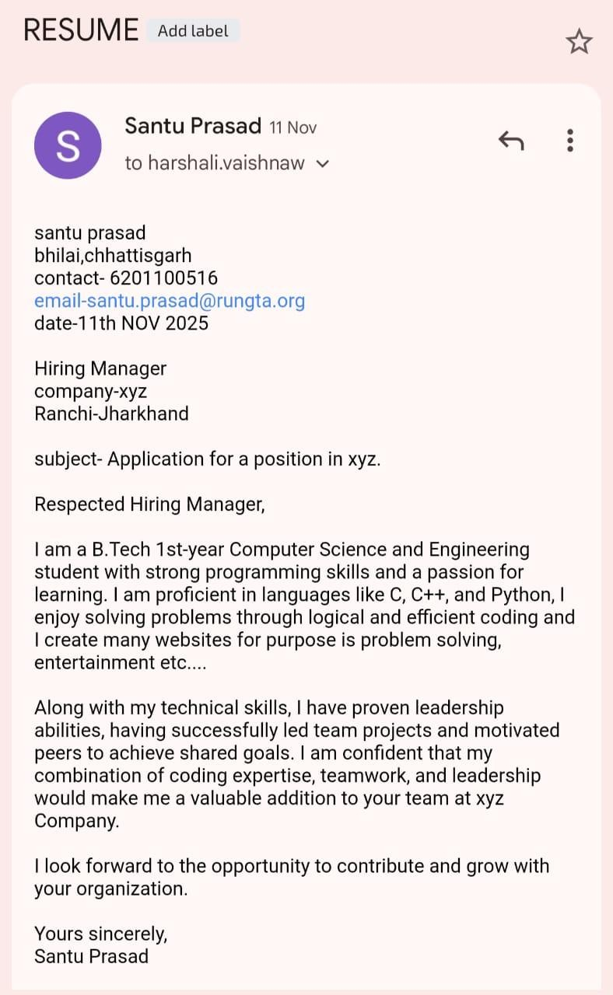
-
kanij.ayesha@rungta.org
Kanij Ayesha
K
Design a complete Google Form survey and analyze responses.
- Create a Google Form titled “Student Attendance Report”.
- Include the following question types:
- 5 MCQs
- 1 Rating scale (1–5)
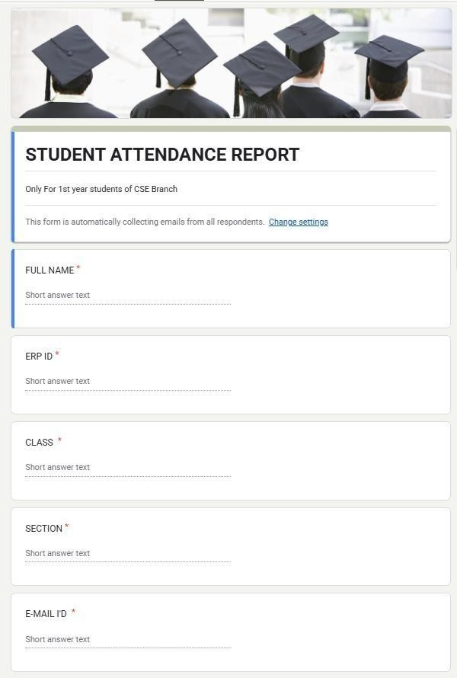
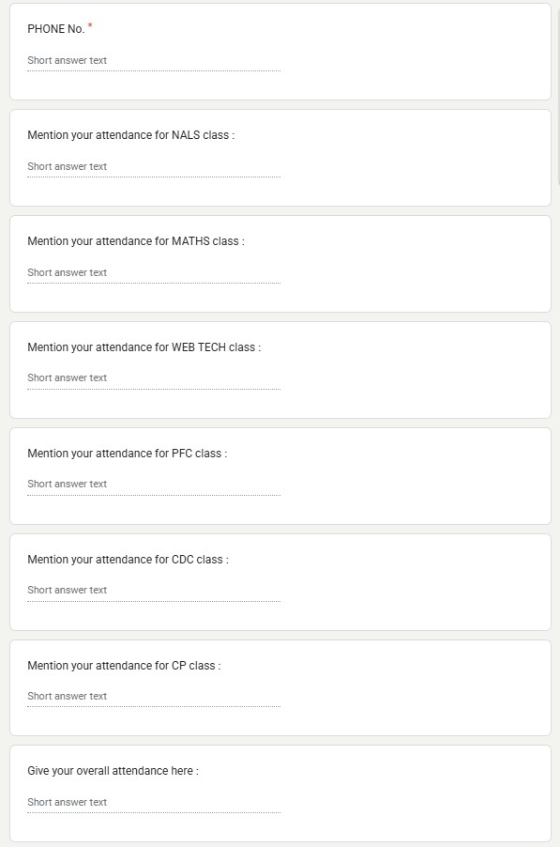
- 1 Short answer
- 1 Checkbox question
- Customize the theme (header image + color).
- Share the form link with 5 friends and collect responses.
- Generate charts from responses and take screenshots of the analysis page.
Sol:

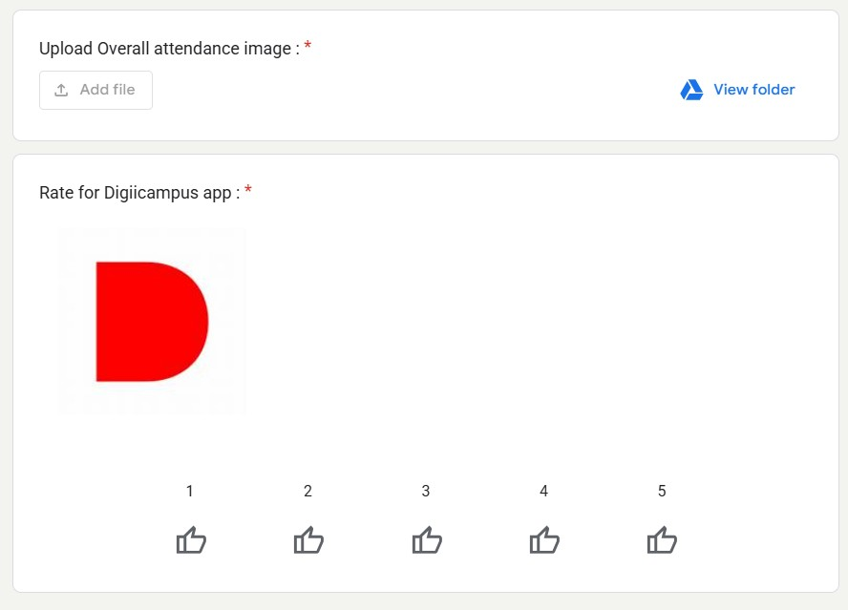
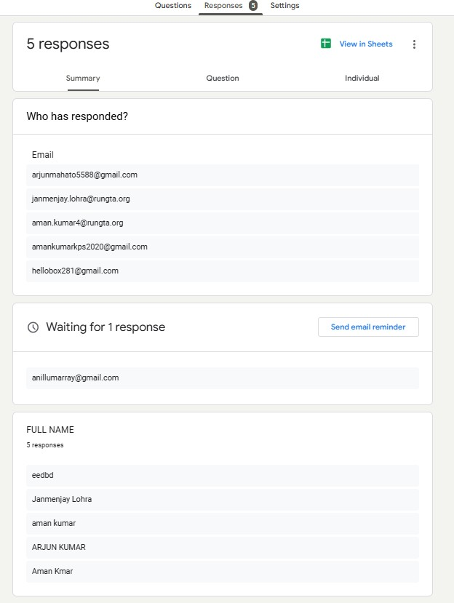
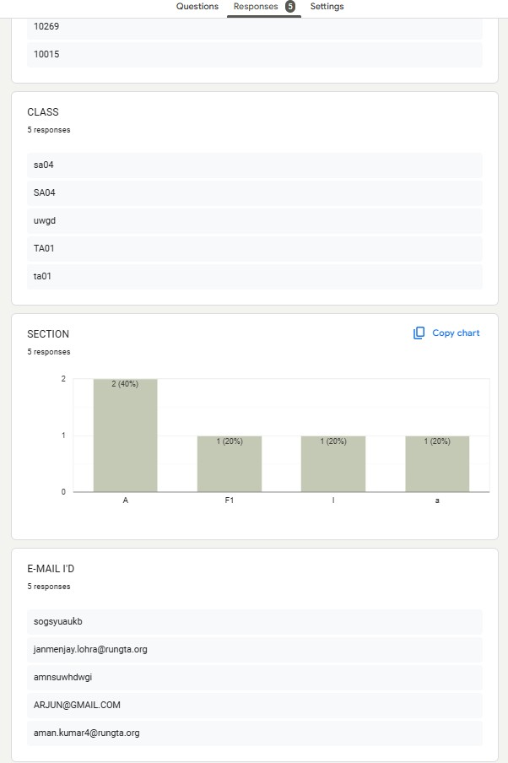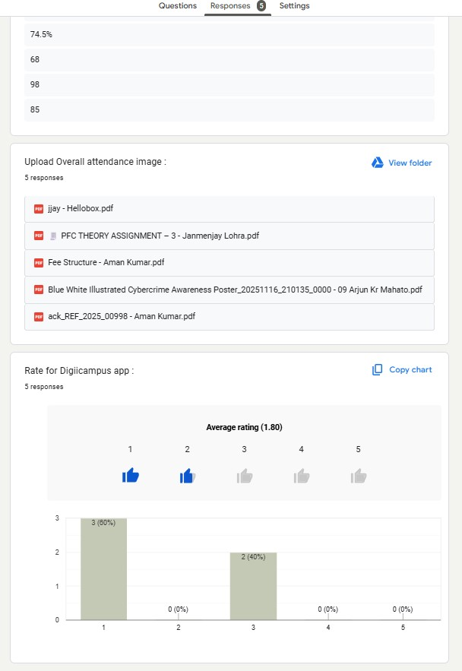

QUESTION 6
Demonstrate the creation and management of your digital identity.
- Create a social media profile (LinkedIn preferred).
- Add a profile photo, short bio, skills, and education details.
- Create a simple post about “My Learning Journey in Digital Literacy.”
- Change your privacy settings to:
- Who can see your posts.
- Who can message you.
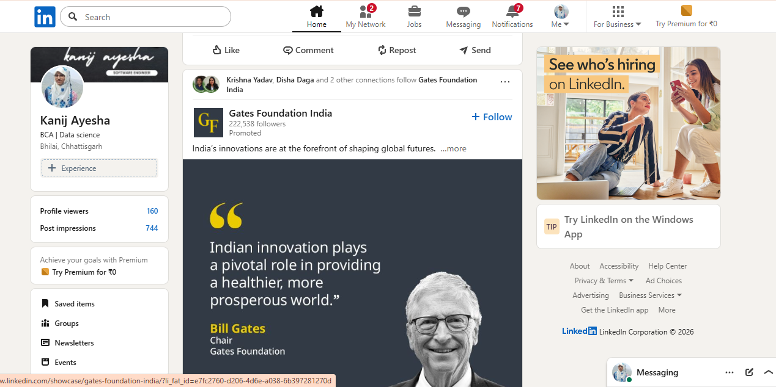
Sol:

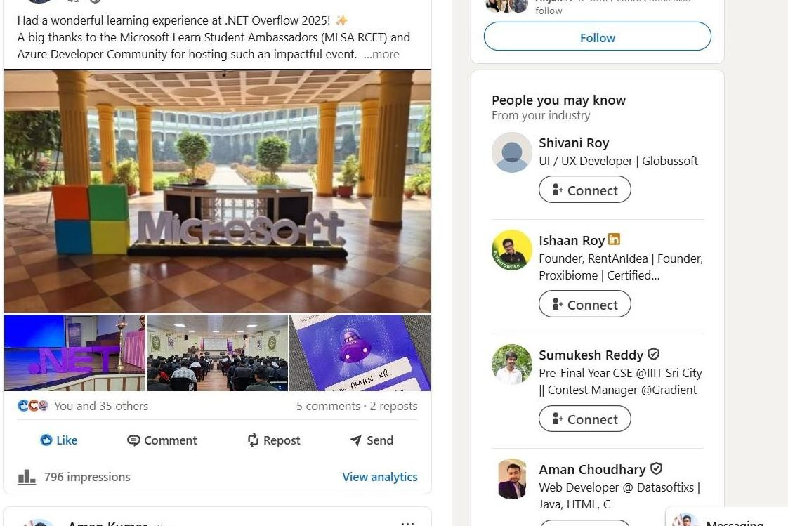
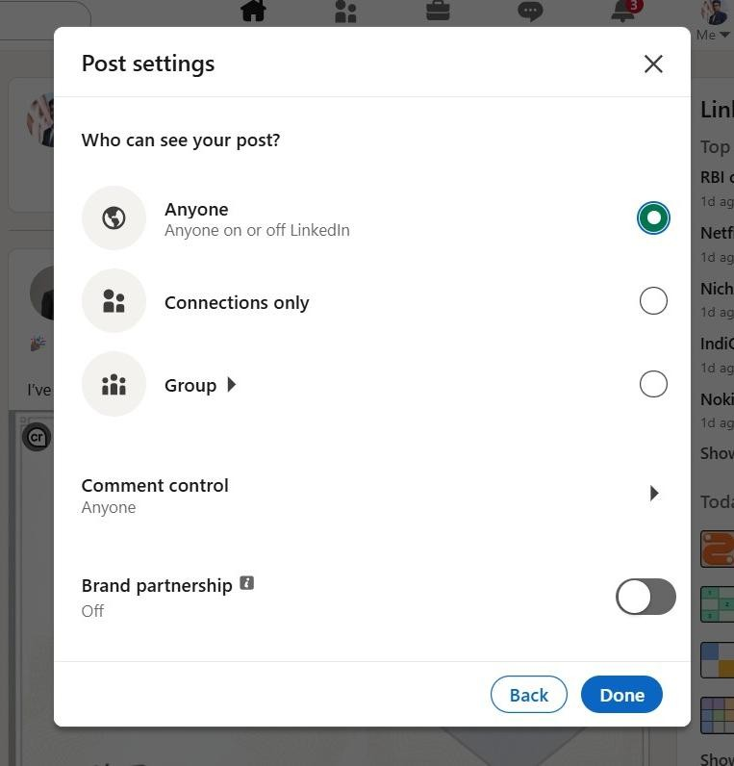

Using Google Drive or OneDrive:
- Create a new folder named “Unit 3 Practical Work”.
- Upload 3 di◻erent files (PDF, image, document).
- Organize them in subfolders: Notes, Images, Assignments.
- Share the main folder with your teacher with View Only permission.
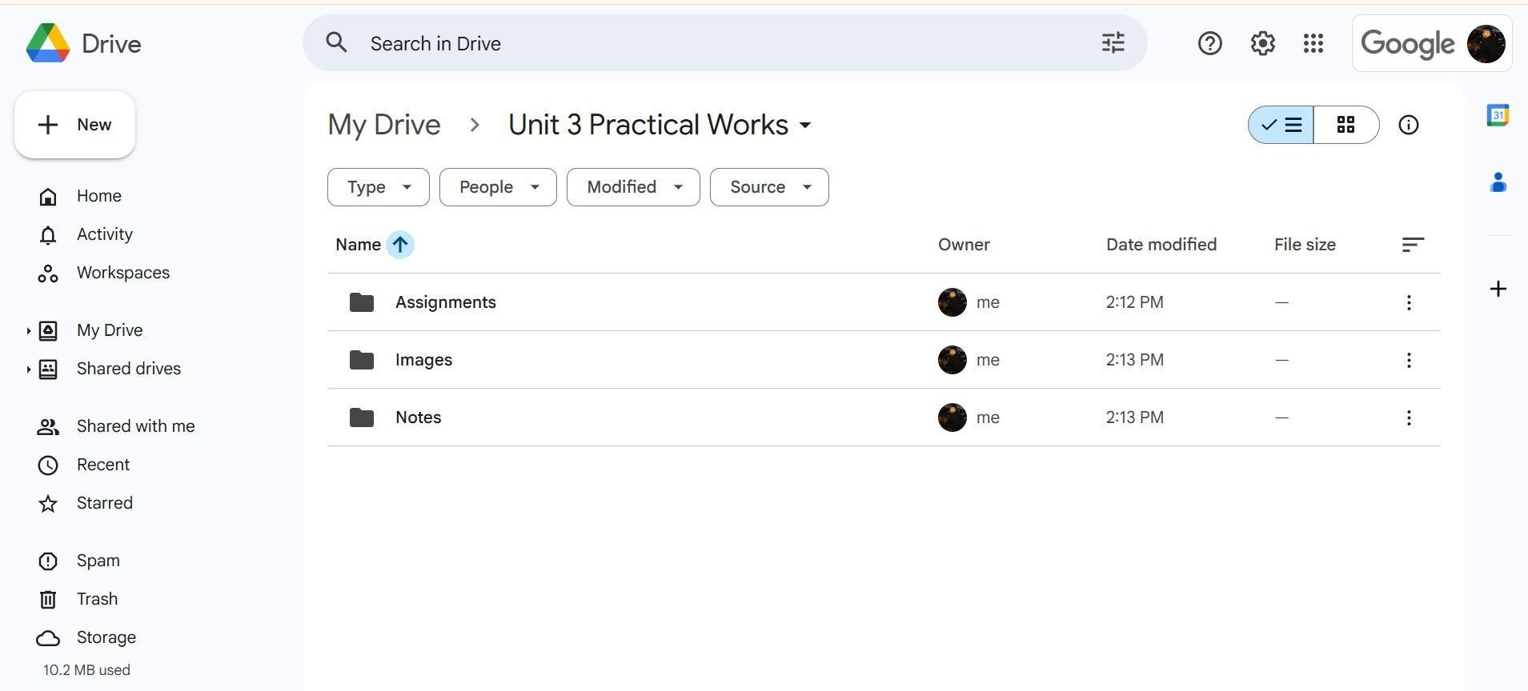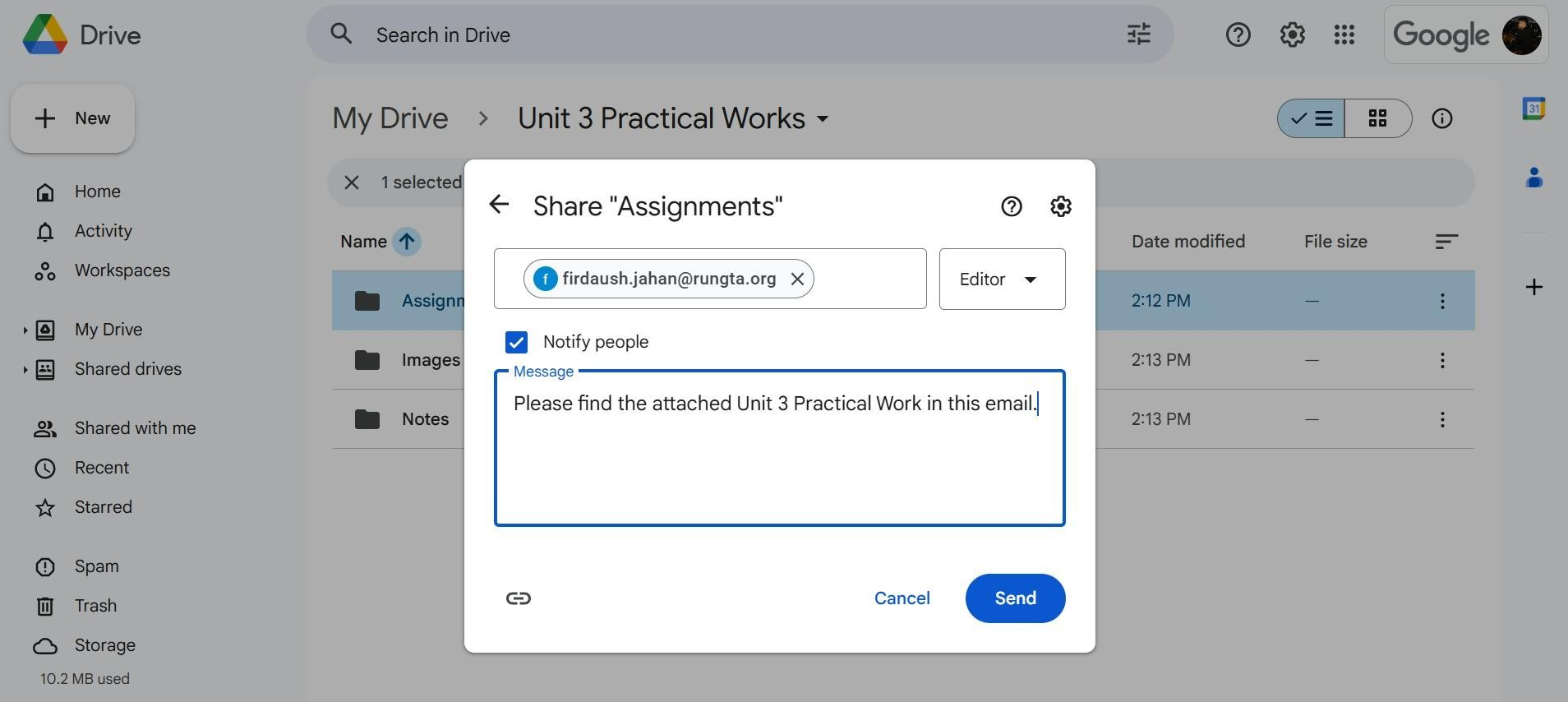
Sol:
Identify one real phishing email:
A final-year student, Aman, receives a LinkedIn message saying: “You are shortlisted for a Remote Software Developer role at Google. Salary:
₹18 LPA.
Pay ₹2,499 as verification fee. Limited seats. Pay now to confirm.” ANSWER
THE QUESTIONS:-
- What type of cybercrime is happening here?
- List 3 red flags that show it is a scam?
- What should he do to verify if a job offer is real?
Let me know if you'd like help answering the questions too!
Sol:
- This is a phishing scam — a form of cybercrime where attackers impersonate legitimate organizations to trick individuals into giving up money or personal information.
- List 3 red flags that show it is a scam:
- Request for money upfront — Legitimate companies like Google never ask for a verification fee.
- Too-good-to-be-true offer — ₹18 LPA for a fresher without an interview is suspicious.
- Urgency and pressure — “Limited seats. Pay now to confirm” is a classic tactic used by scammers to rush victims.
c) What should he do to verify if a job offer is real?
- Check the official company website or careers page for job listings.
- Contact the company directly through verified channels to confirm the o◻er.
- Look for professional email domains (e.g., @google.com) instead of generic or social media messages.
Create a Google Form Quiz with the following requirements:
- Convert the form into a Quiz mode with automatic grading.
- Add 5 MCQ questions, each carrying 2 marks.
- Add 1 short answer question that requires manual evaluation.
- Turn ON the setting:
- Limit to 1 response
- Shu◻le question order
- Release marks after manual review
5. Add a timer add-on (like form presenter) and set up a 10-minute time limit Sol:
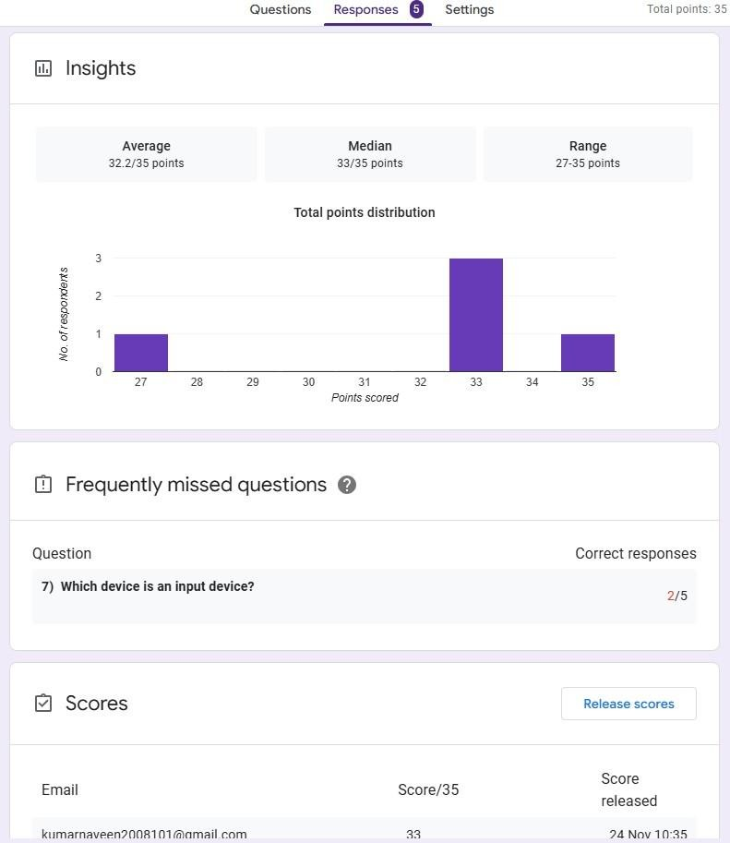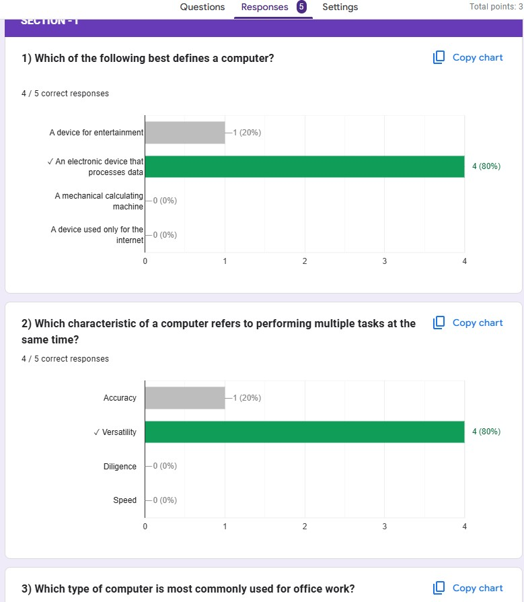

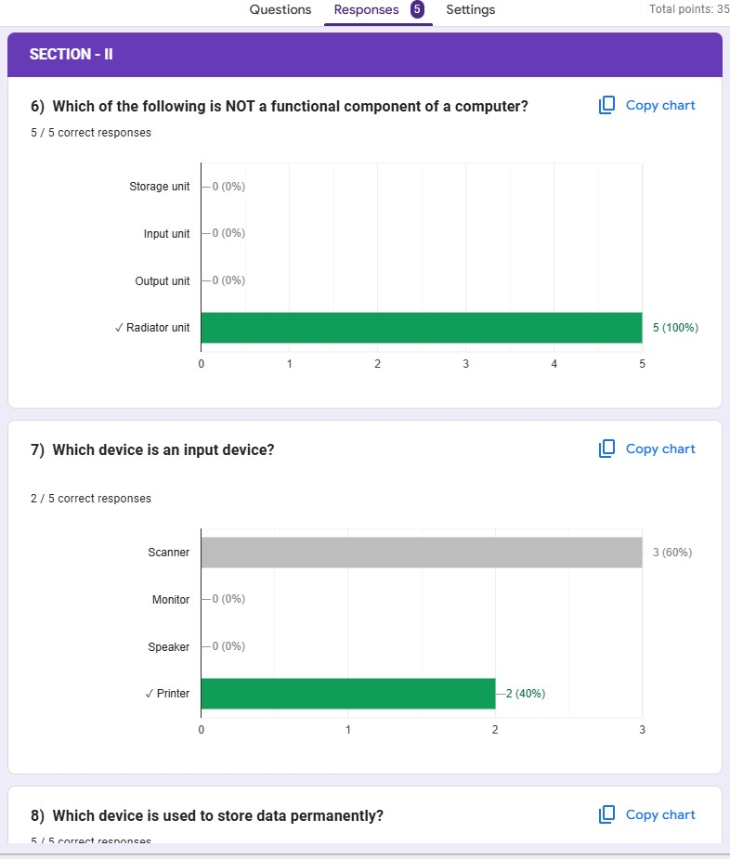
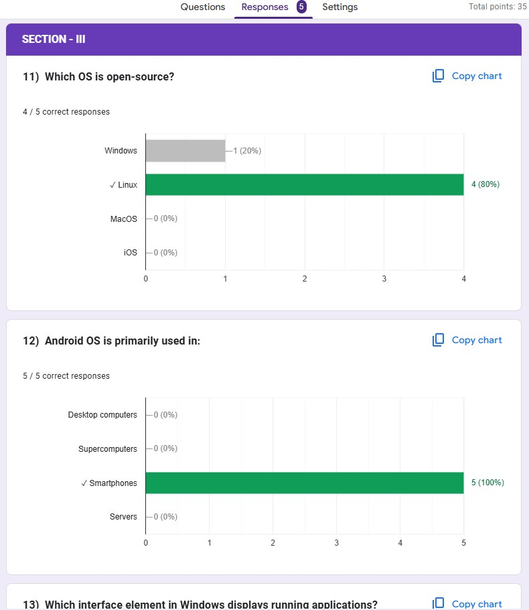

QUESTION 10
Ask ChatGPT OR Google Gemini to generate a 100–120 word paragraph on:
“Is online learning better than offline learning for college students?
” a) Run the AI-generated text through Grammarly and any plagiarism-check tool.
- Now manually search online to check if similar sentences exist on blogs or articles.
- Identify 2–3 biased statements in the AI answer, such as:
- Over-generalizations
- One-sided opinionsiii. Unproven claims
d). Rewrite the entire paragraph in a neutral and balanced way, using AI only for grammar suggestions e) Submit 3 screenshots:
i. Plagiarism check result ii. Grammarly suggestion page
- Original AI paragraph vs your rewritten unbiased versionSol:
i):
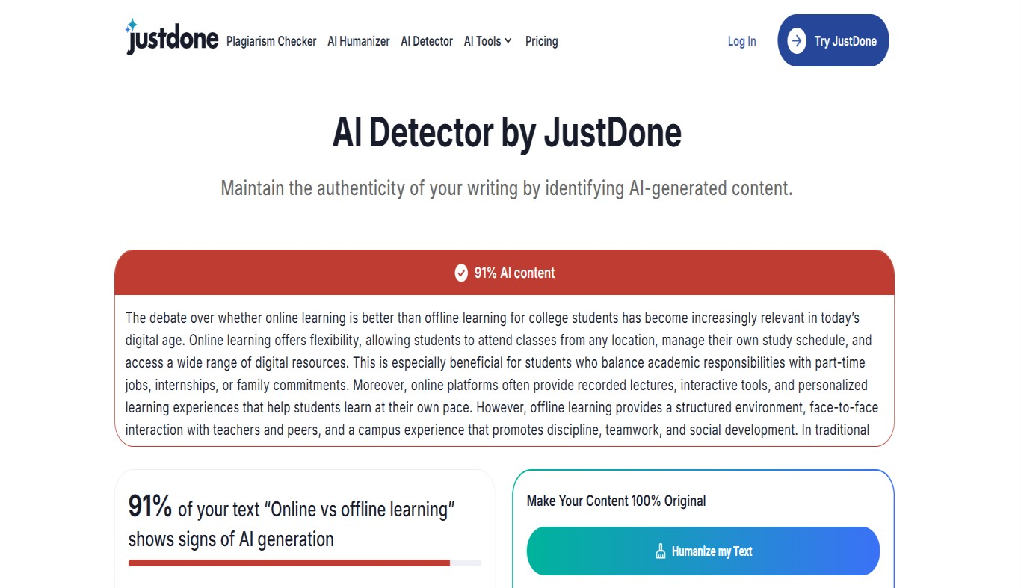
ii):
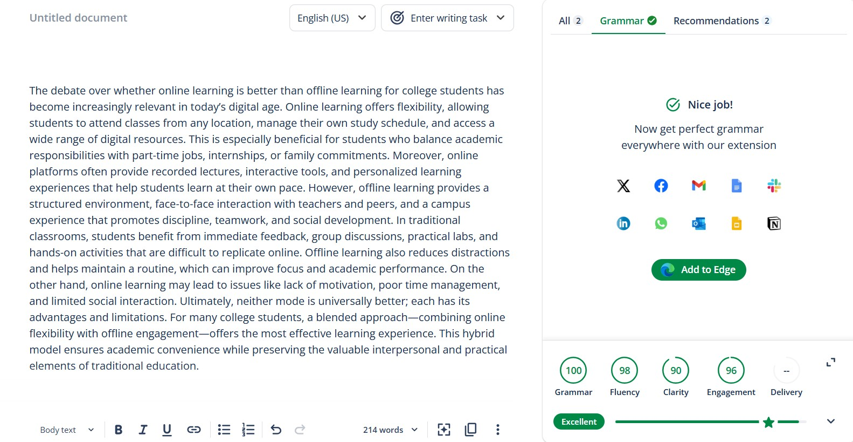
iii):
Ai-generated

The debate over whether online learning is better than offline learning for college students has become increasingly relevant in today’s digital age. Online learning offers flexibility, allowing students to attend classes from any location, manage their own study schedule, and access a wide range of digital resources. This is especially beneficial for students who balance academic responsibilities with parttime jobs, internships, or family commitments. Moreover, online platforms often provide recorded lectures, interactive tools, and personalized learning experiences that help students learn at their own pace. However, offline learning provides a structured environment, face-to-face interaction with teachers and peers, and a campus experience that promotes discipline, teamwork, and social development. In traditional classrooms, students benefit from immediate feedback, group discussions, practical labs, and hands-on activities that are difficult to replicate online. Offline learning also reduces distractions and helps maintain a routine, which can improve focus and academic performance. On the other hand, online learning may lead to issues like lack of motivation, poor time management, and limited social interaction. Ultimately, neither mode is universally better; each has its advantages and limitations. For many college students, a blended approach—combining online flexibility with offline engagement—offers the most effective learning experience. This hybrid model ensures academic convenience while preserving the valuable interpersonal and practical elements of traditional education.
Your rewritten unbaised version

People keep debating if online learning works better than in person for college students. This question feels more important than ever with all the digital stuff around us today. Online classes give a lot of flexibility. Students can join from anywhere they want. They set their own schedules for studying. Plus they get access to tons of digital materials. That setup really helps those juggling school with jobs on the side or internships. It also fits people dealing with family stuff at home. On top of that online sites usually have recordings of lectures. They include interactive features too. And they offer ways to learn that match each persons speed. Still traditional learning brings a solid structure to things. You get real face to face talks with teachers and other students. The whole campus vibe pushes discipline and working together. It builds social skills in a natural way. In regular classrooms feedback comes right away. Group chats happen live. Labs and hands on work feel more real there. Those elements prove hard to match on the web. Offline setups cut down on distractions overall. They help build steady
habits that sharpen focus. That can boost how well students do in their courses. Online ways sometimes cause problems though. Motivation might drop off. Time slips through fingers easily. Social connections stay limited too. In the end no single approach wins for everyone. Each style carries its strengths along with some downsides. For a bunch of college folks blending the two makes the most sense. Mixing online ease with in person involvement creates strong results. This combined method keeps things convenient for schoolwork. At the same time it holds onto the key personal touches and real world parts from old school teaching.

QUESTION 11
To compare AI-generated content with student-created content and understand limitations of AI.
- Write a 100–150 word paragraph on the topic: “Will AI replace jobs or change them?” (This must be written by the
student.)
- Ask any AI tool (ChatGPT/Gemini/Copilot) to write the same topic
. c) In your practical copy, create a Comparison Table with the headings:
I. Human-Generated Content II. AI-Generated Content Sol:
- AI has already begun to change how we perform tasks in the present workplace. The key question is, will AI lead to the total destruction of human jobs, or simply the restructuring of jobs in ways previously not possible? It is highly probable that AI will take away jobs based on repetitive and routine tasks such as data entry and basic customer service. With machines being faster and producing far fewer errors than humans at these types of jobs, it will be difficult for people to compete with AI.
While there will be diminishing numbers of jobs being performed by humans due to AI taking over those duties, there will still be a high demand for workers who know how to use AI, as the employment of some industries will not go away, but will require more creativity and innovative thinking. For example, healthcare, education, engineering, and marketing all currently use AI technology to make processes more efficient, which opens the door for employees to spend less time on simple tasks and move towards a more creative work environment focused on problem-solving, critical thinking, and effective decision-making.
In addition to less traditional jobs disappearing as a result of AI technology, new job opportunities are being created through the use of AI technology. Jobs such as data analysts, AI developers, automation specialists, and prompt engineers are becoming more important as the development of new technologies expands.
To sum up, AI technology will ultimately change more jobs than replace them, and the sooner a worker can transition their skills to accommodate AI technology, the better off that worker will be.
- Artificial Intelligence is transforming the way we work, and the main question is whether it will
replace human jobs or simply change them. AI is likely to replace jobs that involve repetitive, routine, and predictable tasks, such as basic data entry or simple customer support. Machines can perform these tasks faster and with fewer mistakes.
However, AI will not remove most jobs; instead, it will change how people work. Many industries, including healthcare, education, engineering, and marketing, are using AI to increase efficiency. This means workers will shift from doing simple tasks to focusing on creative thinking, problem-solving, and decision-making.
AI is also creating new career opportunities, such as data analysts, AI developers, automation experts, and prompt engineers. These fields are becoming important as technology grows.
Overall, AI will change jobs more than it replaces them. People who learn new skills and adapt to technology will benefit the most

QUESTION 12
) Upload multiple sources (any 2) such as:
- PDF notes
- Web articlesiii. Text copied into NotebookLM
b) Ask NotebookLM to:
- Create a combined study guide using all sources.
- Generate flashcards for quick revision
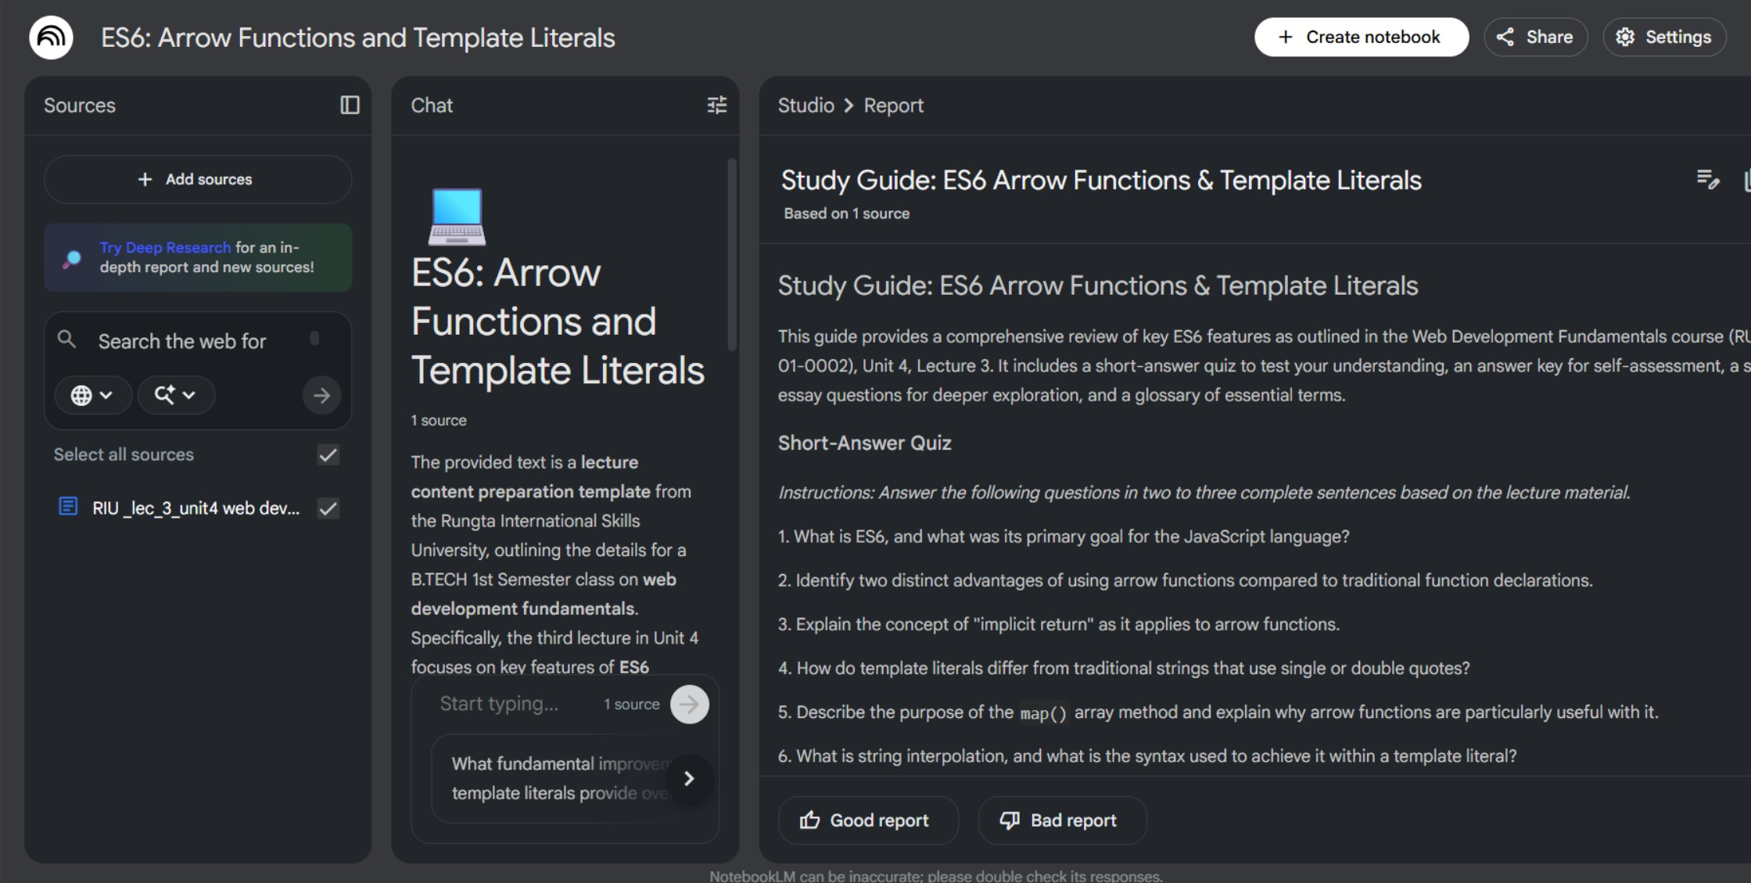
. iii. Create a concept map or explanation of the topic.
c) Manually check for:
i. Any incorrect facts ii. Repeated information iii. Missing important points
d) Attach 3 screenshots from NotebookLM:
i. Combined study guide ii. Flashcards
Concept map / explanation Sol:

